Prerequisities
Questions on HTML

What is HTML and its uses?
HTML stands for HYPER TEXT MARKUP LANGUAGE, and is a markup language.
Hyper – stands for ANCHOR or HREF element
Example: <a href
Text – stands for the text in document.
MARKUP LANGUAGE – stands for the structure of document using elements like heading paragraph, link and more.
HTML is used to create User Interface components (collection of UI components).
HTML is a language used to create UI components, html will provide elements and each and every element provides some format called as tags with help of these creating UI components.
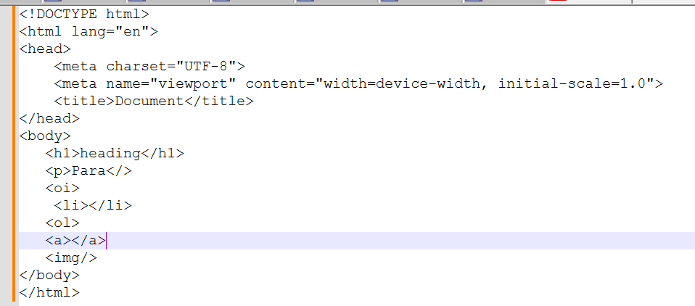

Element in HTML?
An HTML element is a component or building block of an HTML document, Elements will structure the HTML document.
An element is a part of a web page that is defined by a start tag, content, and an end tag. Elements can contain other elements, as well as text, images, videos, audio, and other types of content.

Tag in HTML?
Tag is a format of elements that structure the content on a web page. HTML tags are enclosed in angle brackets < >, and consist of two types: self-closing tag paired tag.

What are the new features introduced in HTML5?
Semantic elements: <header>, <footer>, <section>, <article>
Multimedia: <audio>, <video>
Graphics: <canvas>, <svg>
Form enhancements: <input type="date">, <input type="email">, placeholder, required
Local storage: localStorage, sessionStorage
Geolocation API

What is the difference between id and class?
- id is unique; used once per page.
- class can be used multiple times; ideal for styling multiple elements.

What is the difference between <section>, <article>, <aside>, and <div>?

How does the HTML5 DOCTYPE declaration look and why is it simplified?

Explain the concept of semantic HTML. Why is it important?

What are data- attributes? How and when should you use them?*

How does HTML5 handle offline storage? Compare localStorage vs sessionStorage vs cookies.

Describe semantic tags.

Semantic tags describe the meaning of the content:
- <article> – self-contained content
- <aside> – sidebar content
- <nav> – navigation links
- <main> – main document content

Questions on CSS

What is CSS and its uses?
CSS stands for Cascading Style Sheets, and it is a language used for styling and formatting HTML elements or UI components how it should display on web page.
Using CSS properties HTML elements will be styled up.

Questions on JAVASCRIPT

What is JavaScript and its purpose?
High level Programming interpreted language primarily used to create interactive and dynamic content on UI.
Purpose of JavaScript:
- Client-Side Scripting: JavaScript is mainly used for client-side development, it runs in the user's web browser without the need for server-side processing.
- DOM Manipulation: JavaScript can interact with the Document Object Model (DOM), enabling developers to modify the content and structure of web pages dynamically.
- Event Handling: JavaScript allows developers to respond to user interactions such as clicks, key presses, or form submissions, making web pages more interactive.
- Form Validation: JavaScript can validate user input in forms before submitting data to the server
- Asynchronous Operations: JavaScript supports asynchronous programming through techniques like callbacks, promises, and async/await.
- Web APIs Integration: JavaScript can interact with various web APIs (e.g., Geolocation API, Fetch API, Web Storage API) to enhance functionality, such as retrieving data from a server, storing data locally, or accessing the user’s location.
- Cross-Platform Development: With environments like Node.js, JavaScript can also be used for server-side development, enabling the creation of full-stack applications. It's also used in mobile app development (e.g., React Native) and desktop applications (e.g., Electron).

Explain what kind of application we can built using Javascript.
variety of applications across different platforms.
- Web Application
- Mobile Application
- Desktop Applications etc

What is .classList in JavaScript?
.classList is a JavaScript property used to access the list of CSS classes assigned to an HTML element. It provides methods to add, remove, toggle, or check classes on that element.

What are variables and explain the rules to create a variable
Variables in JavaScript are used to store data that can be referenced and manipulated within a program.
Rules to follow while making use of variables
- Variable name should contain only letter,digits,symbols($) and (_)underscore
- First character must not be the digits
- Variable Names should be in camelCase

What are Data types
Data types define the kind of data that can be stored and manipulated within a program.
- Primitive Data Types:
- Non-Primitive Data Types

Explain Primitive and Non-Primitive Data type.
Data type used to store single value are known as Primitive data types Primitive Data Types: String, Number, Boolean, Undefined, Null, Symbol, BigInt.
Data types are used to store multiple values are known as Non-Primitive Data types
Non-Primitive Data Types: Object (which includes Arrays, Functions, Dates, etc.).

What is function in Javascript
Reusable block of code designed to perform a specific task. Functions allow you to encapsulate logic and avoid code repetition

Explain the Difference between callback and higher order function in JS?
Callback Functions
A callback function is a function that is passed as an argument to another function.
Callbacks are often used for asynchronous operations, like handling events, making API requests, or performing tasks after a delay.
callback function is executed after some operation has been completed.

A higher-order function is a function that either:
- Takes one or more functions as arguments, or
- Returns a function as its result.

What is difference between let , cons and var
- Hoisting
- Scope/Memory
- Redeclaration/ Updating
Hoisting means it is a mechanism where it moves the variable/function declaration to the top of its nearest scope
Example
Var | Let | Const
console.log(a); | HOISTING will not support
var a = 10;
Internally var a;
console.log(a);
//nearest scope a = 10 ;
SCOPE/Memory var is a function level scope | let/const are block level scope { }
var supports redeclaration and Updation | let supports only Updation | with const no redeclaration /Updation

Smart Answer
- var is function-scoped and allows hoisting but is prone to bugs due to re-declaration.
- let is block-scoped and prevents re-declaration.
- const is also block-scoped, and its value cannot be reassigned. However, objects declared with const can still have their properties modified.

What is spread operator
Getting new array with the existing array values but not same array.
the spread operator is used to expand elements from an array or object into individual elements.

What is Rest Parameter
Rest parameter is used in function definitions to gather multiple arguments into an array, whereas

What is promise in Javascript
Promises simplify the handling of asynchronous code. if code tooks long time then the below code needs to wait for the current execution.
• Methods:
- then(): Handles fulfillment and optionally rejection.
- catch(): Handles rejection.
- finally(): Runs regardless of fulfillment or rejection.
• Advanced Methods: Promise.all(), Promise.race(), Promise.allSettled(), Promise.any().

Explain different States of Promise in Javascript
• States: Pending, Fulfilled, Rejected.
How to create a Promise
const promise = new Promise((resolve, reject) => {
setTimeout(() => {
const input = "ABC";
if (input) {
resolve(input);
} else {
reject(new Error("no data"));
}
}, 5000);
});

promise
.then((input) => {
console.log(input);
})
.catch((err) => {
console.log(err);
})
.finally(() => {
console.log(Test);
});

What is difference between promise and callback in Javascript
- Callbacks: Functions passed to other functions to be executed later. Can lead to deeply nested code and complex error handling.
- Promises: Objects that represent the completion of asynchronous operations. Provide better readability, chaining, and error handling.
Promises are generally preferred over callbacks for handling asynchronous operations due to their cleaner syntax, better error management, and improved composability.

What is Callback
A callback is a function that is passed as an argument to another function to be "called back" at a later time(exception, deadlock, successful)

What is higher order function in Javascript
- Higher-Order Function: A function that either accepts functions as arguments or returns a function.
  - Accepting Functions: Allows customization and flexibility by passing functions as arguments.
  - Returning Functions: Enables dynamic creation of functions with specialized behavior.
Higher-order functions enhance code modularity, readability, and reusability, making them an essential concept in modern JavaScript programming.

Explain different types of function in Javascript
functions are the building blocks
Allow not to repeat the code
Function Declaration and Function Expression
=> with function declaration calling is possible without declaration
=> with function expression calling is not possible without declaring it

What is arrow function in Javascript
Arrow functions are useful for creating short and readable functions, A concise way to write function expressions
Syntax: (parameters) => { body }

Why we use call, apply bind method in
call: Invokes the function immediately with a specified this and arguments.
apply: Invokes the function immediately with a specified this and an array of arguments.
bind: Creates a new function with a specified this and optional pre-filled arguments, to be invoked later.

How many ways to create object in Javascript
- Object Literal Notation: {} syntax.
- Using new Object(): new Object().
- Object.create(): Creates objects with a specified prototype.
- Constructor Functions: Functions used with the new keyword.
- ES6 Classes: class syntax.
- Factory Functions: Functions that return new objects.

What is the array method , string method

What is difference between java and javascript

What is Null and undefined in javascript.
In JavaScript, both null and undefined represent the absence of a value
undefined is a primitive value that indicates that a variable has been declared but not yet assigned a value.
in javascript null means "reference to non existing object "
typeof a => object
//clearing of values.
null is a primitive value that represents the intentional absence of any object value. a variable should have no value or that an object reference is empty.

What is setTimeOut and setInterval in Javascript

What is sessionStorage, localStorage

What are is map, filter , reducer in javascript

What is closure in Javascript

What is hoisting in Javascript

What is the difference between array and object

How to make an array empty?
By making the array length = 0; or assigning empty array;
Ler arr = [1,2,3,4]
arr.length = 0 or arr = [];

What is the difference between number type and BigInt type

What is the difference between call() and apply()

What is DOM and DOM Manipulation.
DOM
The Document Object Model (DOM) is a programming interface that represents the structure of HTML and XML documents. It allows JavaScript to access and manipulate the content and structure of a webpage.
DOM Manipulation

JavaScript can interact with the Document Object Model (DOM), enabling developers to modify the content and structure of web pages dynamically.

How to create element dynamically using Javascript

Explain Closures in Javascript .
Closures are functions that have access to variables from an outer function, even after the outer function has finished executing. They encapsulate data and provide a way to maintain state between function calls.

Explain different Scopes in Javascript:
Function level
Any variables, functions or class is declared under a block
Global level:
Any variables, functions or class is not declared under any block
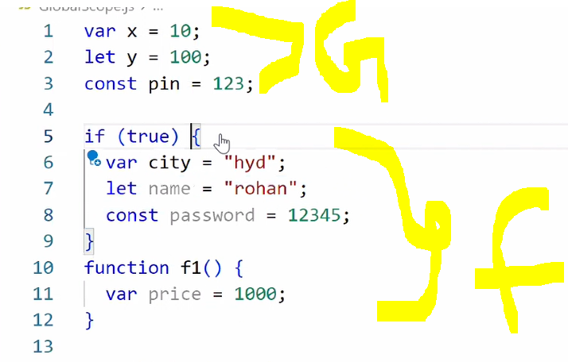
Module level:
Area across your application is considered as a module scope.
Any variables, functions or class is accessible from one file to another file using Named export and default Export.
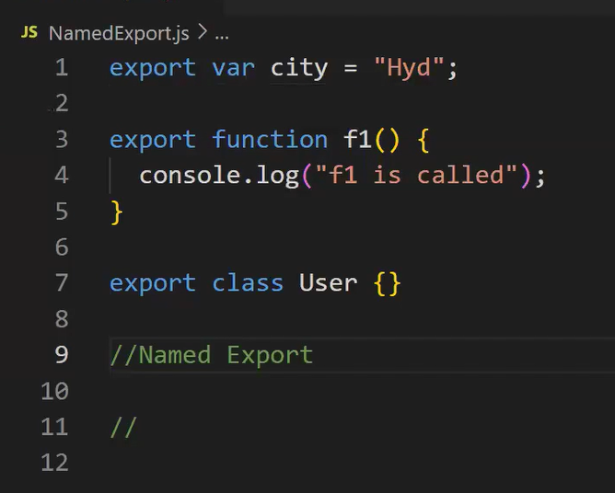
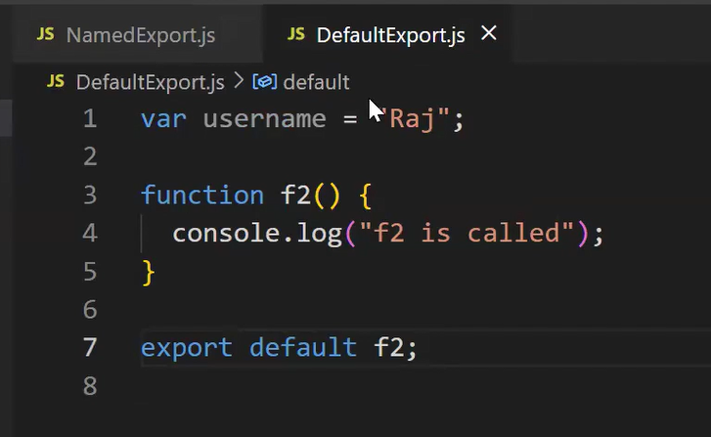

What is import and export

What is Destructing in the Javascript

Difference between Normal Function and Arrow Function
function addition(x, y) {
return x + y;
}
const addition = (x, y) => x + y;

Explain difference between map() and forEach()
Use map() when you need to create a new array by applying a transformation to each element of the original array.
Use forEach() when you need to execute a function for each element of the array without modifying or creating a new array.
map() and forEach() are both methods used to iterate over arrays
forEach | Map
Does not return a new array | Returns a new array with the transformed elements
Since forEach() returns undefined, it cannot be chained with other array methods. | Since map() returns a new array, it can be chained with other array methods like filter(), reduce(), etc.

What are events in Javascript.
Events are actions or occurrences that happen in the browser, can respond to these events by executing code in response.
- Mouse Events
- Keyboard Events
- Form Events etc..

Explain the difference between == and ====
type coercion => converting value from one type to other

1 == "1" => true => type coercion happens so it will check only value.
1 === "1" => false => not do type coercion just check with data type

What is an anonymous function in JavaScript?
An anonymous function is a function without a name. It can be assigned to a variable or passed as an argument to another function. They are often used for onetime or callback functions.

What is the purpose of the filter() function in JavaScript?
The filter() function is used to create a new array containing elements that pass a certain condition defined by a provided function. It allows filtering elements from an array based on specific criteria.

What is the purpose of the reduce() function in JavaScript?
The reduce() function is used to reduce an array to a single value by applying a function to each element and accumulating

What is the difference between function declarations and function expressions in JavaScript?
Function declarations are hoisted and can be called before they are defined, while function expressions are not hoisted and must be defined before they are called.

How do you manage asynchronous operations in large-scale JavaScript apps?
I use Promises and async/await for readable async logic. For large-scale apps:
- I organize API calls in separate services/modules.
- I use error boundaries and global error handling.
- For advanced flows, I may use RxJS, Redux-Saga, or observables when required.
What design patterns do you commonly use in JavaScript projects?
- Module Pattern: To encapsulate and organize code.
- Observer Pattern: For event-driven architecture or pub/sub systems.
- Factory Pattern: For object creation with dynamic behavior.
- Singleton Pattern: For managing global state like auth/session.
- I also follow SOLID principles in my component and service design.
12: Why this is a good lead-level problem:
- Tests understanding of array methods, object manipulation, and clean code.
- Can discuss scalability, immutability, and error handling enhancements.
- Opens up for optimizations using Map, if needed.

